EPU recommended READING LIST
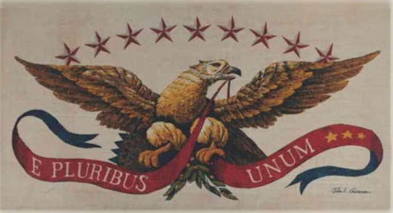
1. Books on the Constitution
a. Creation of the American Republic, 1776-1787, by Gordon S. Wood
b. Novus Ordo Seclorum: The Intellectual Origins of the Constitution, by Forrest McDonald

2. The Federalist Papers by Alexander Hamilton, James Madison and John Jay
a. There are a number of good versions of the Federalist Papers in book form. Some also include the Anti-Federalist papers. These papers are critical to understand the thinking behind the proposed national constitution.

3. Democracy in America by Alexis de Tocqueville
a. Written 50 years after the French Revolution, de Tocqueville’s work is important to understand how a visitor saw the United States as the most advanced country in creating political and social equality in its citizenry. Though he was very impressed with much of what he saw in American life, he also did not ignore the obvious dichotomy between political and cultural freedom and the institution of slavery.

4. Abraham Lincoln: Great Speeches, by Abraham Lincoln

