EPU recommended REFERENCE MATERIALS
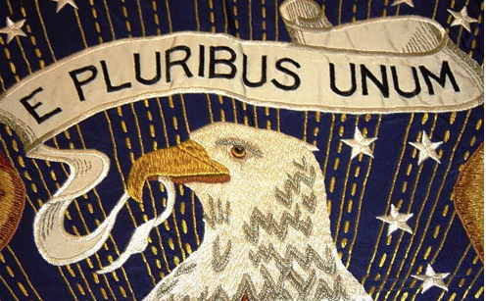
1. The Heritage Foundation Guide to the Constitution.
a. This is an excellent resource. The complete text of the Constitution is presented. By clicking on any clause in the text the reader can dig deeper into the issues and history surrounding that particular clause. Further Reading, Case Law and Related Essays are available at the bottom of each page.
i. https://www.heritage.org/constitution

2. Full Text of the Federalist Papers by the Library of Congress.
a. On the left side of the homepage under the list of Federalist papers, some very interesting ‘Related Digital Resources’ that warrant further examination.
i. https://guides.loc.gov/federalist-papers/full-text

3. The Founders Online
a. Correspondence and other writings of seven major shapers of The United States: George Washington, Benjamin Franklin, John Adams (and family), Thomas Jefferson, Alexander Hamilton, John Jay, and James Madison. Over 185,000 searchable documents, fully annotated, from the authoritative Founding Fathers Papers projects.
i. https://founders.archives.gov/
b. James Madison and the Vices of the Political System of the United States, April 1787
i. https://founders.archives.gov/documents/Madison/01-09-02-0187

