EPU recommended VIDEOS/PODCASTS
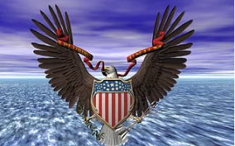
The Declaration of Independence and The Constitution of the United States.
1. The U.S. Constitution Explained
a. A short and somewhat lighthearted overview of the organization of the Constitution and why it works. A little dated (2019) with regard to Presidents who have been impeached but good nonetheless.
i. https://www.youtube.com/watch?v=1xklT6515RI

2. Hillsdale College Online Courses, Constitution 101, The Meaning and History of the Constitution
a. Lecture 1, The Theory of the Declaration and the Constitution
i. https://www.youtube.com/watch?v=oU5gasRxYdU
b. Lecture 2, Natural Rights and the American Revolution
i. https://www.youtube.com/watch?v=wvCWORnRy1A

3. The Bill of Rights
a. Short history of the Bill of Rights—a “hard fought compromise to save the Constitution” and how James Madison saved the Constitution.
i. https://www.youtube.com/watch?v=MVtePB8Iu9E

4. The Federalist Papers
a. The Federalist Papers were written in the summer of 1787 by James Madison, Alexander Hamilton and John Jay to encourage the citizens of New York to ratify the proposed Constitution. Here is a short but useful overview of the Federalist Papers:
i. https://www.youtube.com/watch?v=kU_HSx99zEg

5. Defining Liberty
a. A short but helpful presentation asking the question of when are restrictions of individual liberty necessary.
i. https://www.prageru.com/video/defining-liberty

